VitalMonitor: full usage steps

A. Power on the device
- Power ON the Device by clicking the power button. Give it a few seconds to start up. It first needs to find the MAX30105 sensor. If the sensor is not wired properly, the board halts here and the screen stays blank.
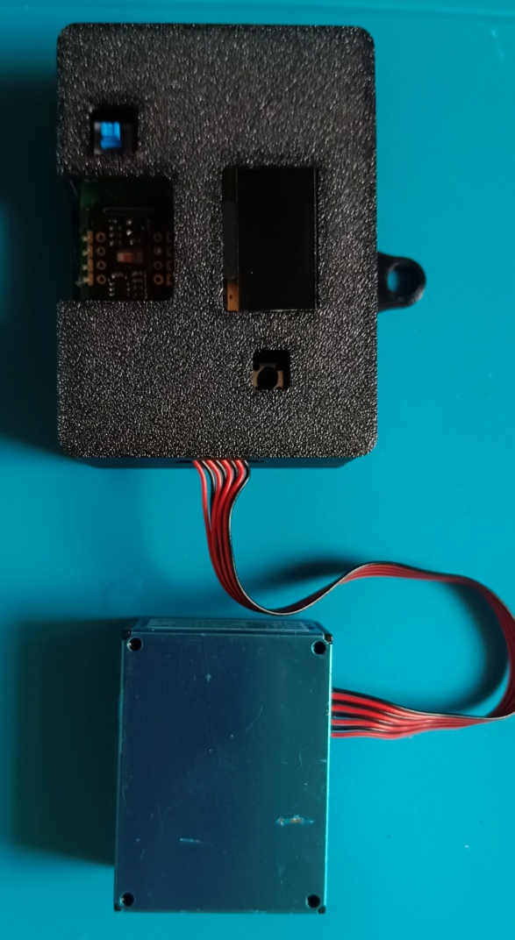
- Check the OLED. When it is ready, it shows "BLE: VitalMonitor / Waiting for app / to connect...".
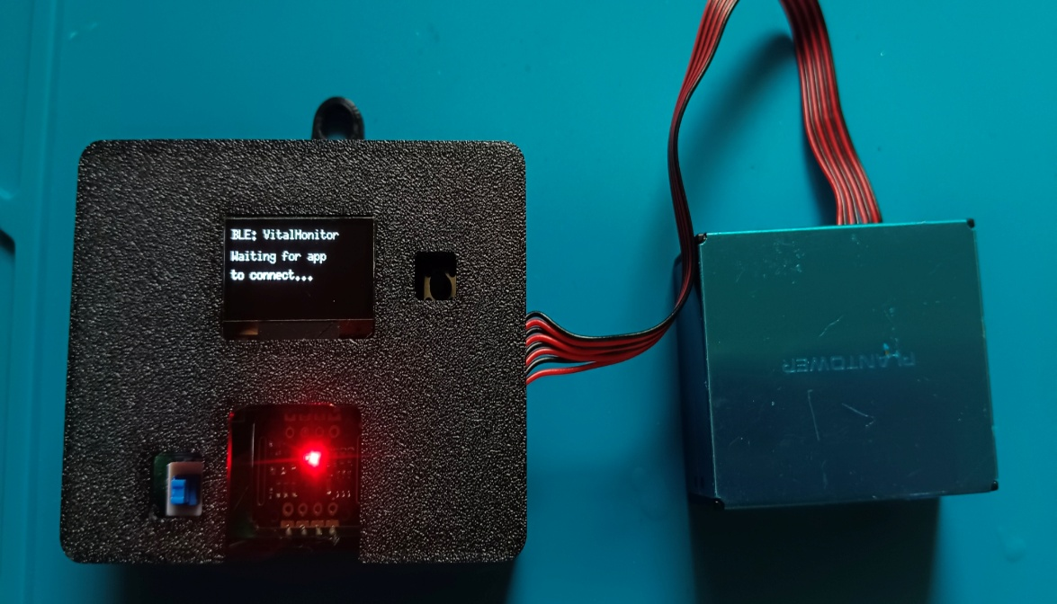

B. Prepare the phone or laptop
- Turn Bluetooth ON.
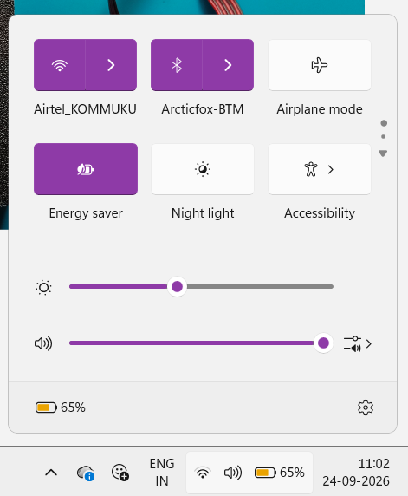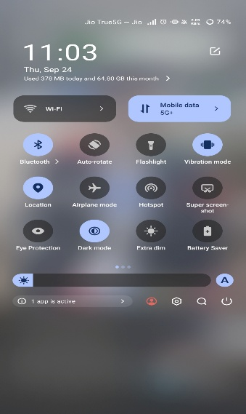
- On Android, also turn Location ON. Chrome will not scan without it.
- Open the page in Chrome or Edge. Safari, Firefox and in-app browsers such as WhatsApp do not support Web Bluetooth.
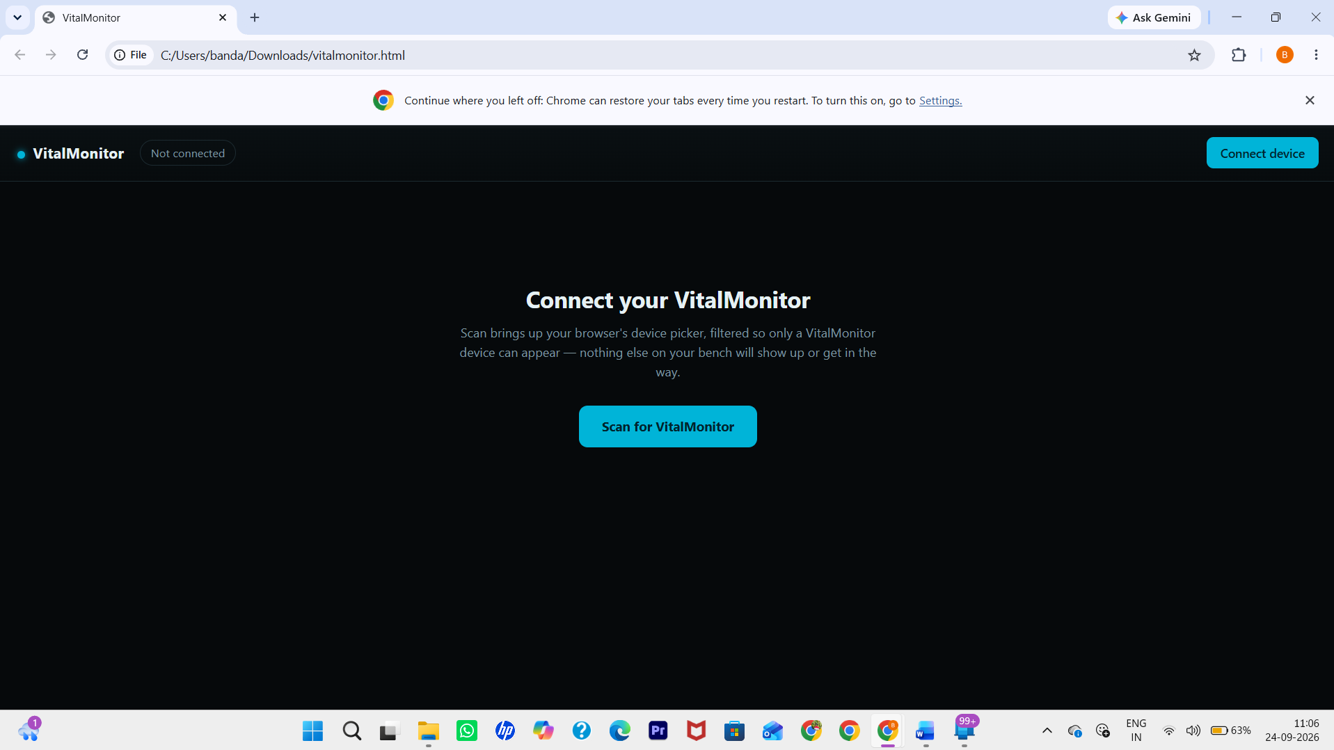
- Make sure you are online the first time. The PDF library loads from the internet.

C. Open the HTML and connect
- Open vitalmonitor.html in Chrome. You will see "Connect your VitalMonitor", and the top bar says Not connected.
- Click Scan for VitalMonitor. You can also click Connect device at the top right.
- The status changes to Scanning…, and a Bluetooth picker pops up.
- Select VitalMonitor and click Pair (or Connect).
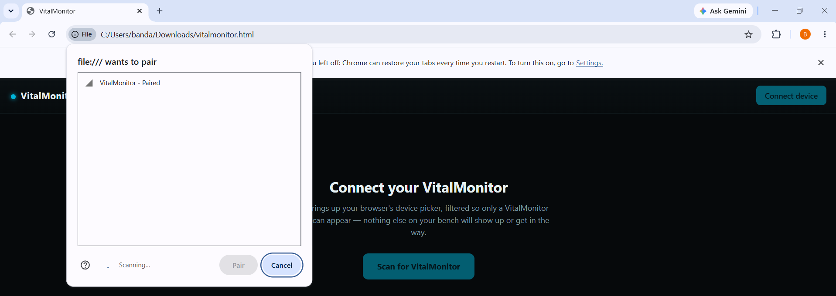
- The status changes to Connecting… and then Connected.
- Check three things to confirm the connection worked:
  - The top bar says Connected.
  - The top-right button now says Disconnect.
  - The OLED shows "BLE: Connected".
The Dashboard, History and Profile tabs also appear. The device clock is set automatically at this point.
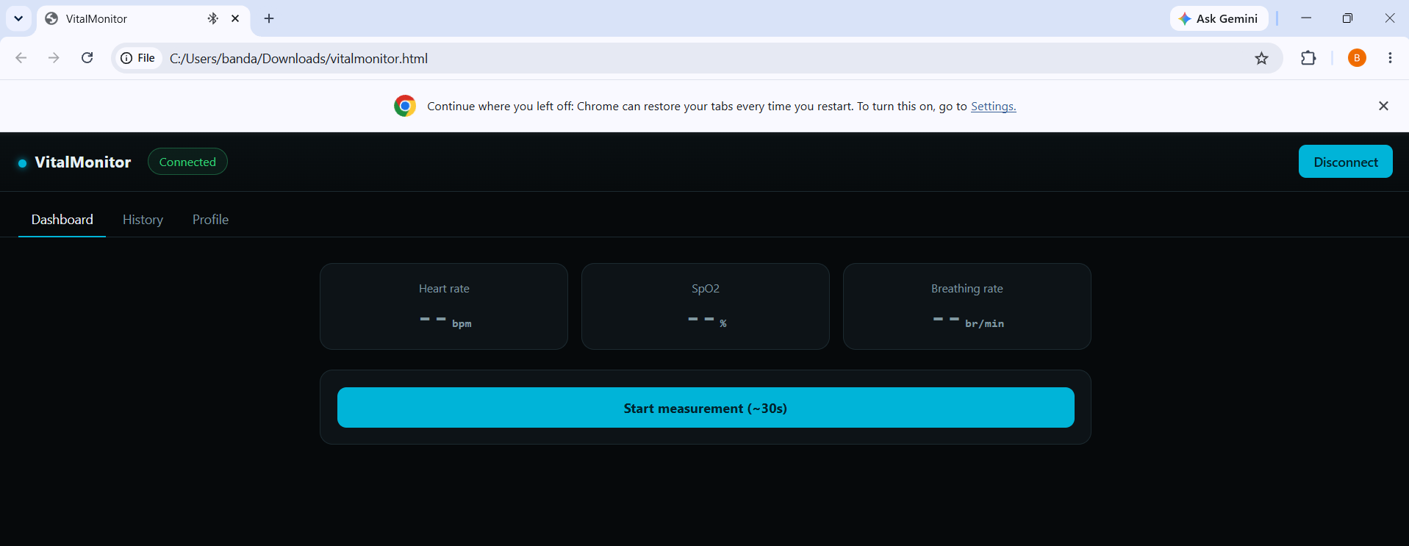
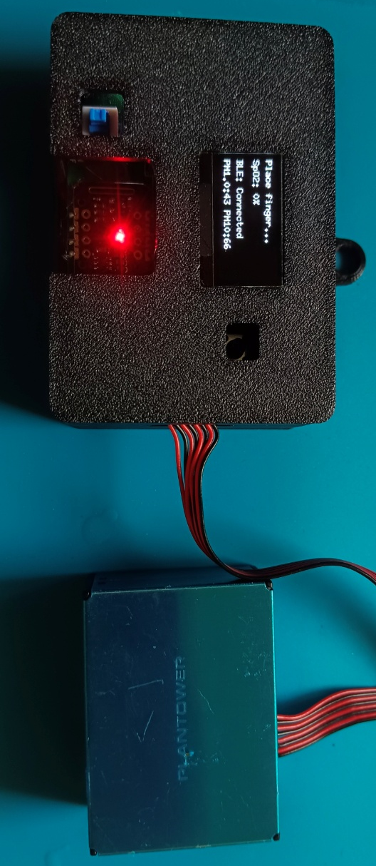
D. Fill in the profile (before your first report)
- Click the Profile tab.
- Enter Name, Age and Gender.
- Click Save profile. A toast message says "Profile saved." This information appears on the PDF reports.
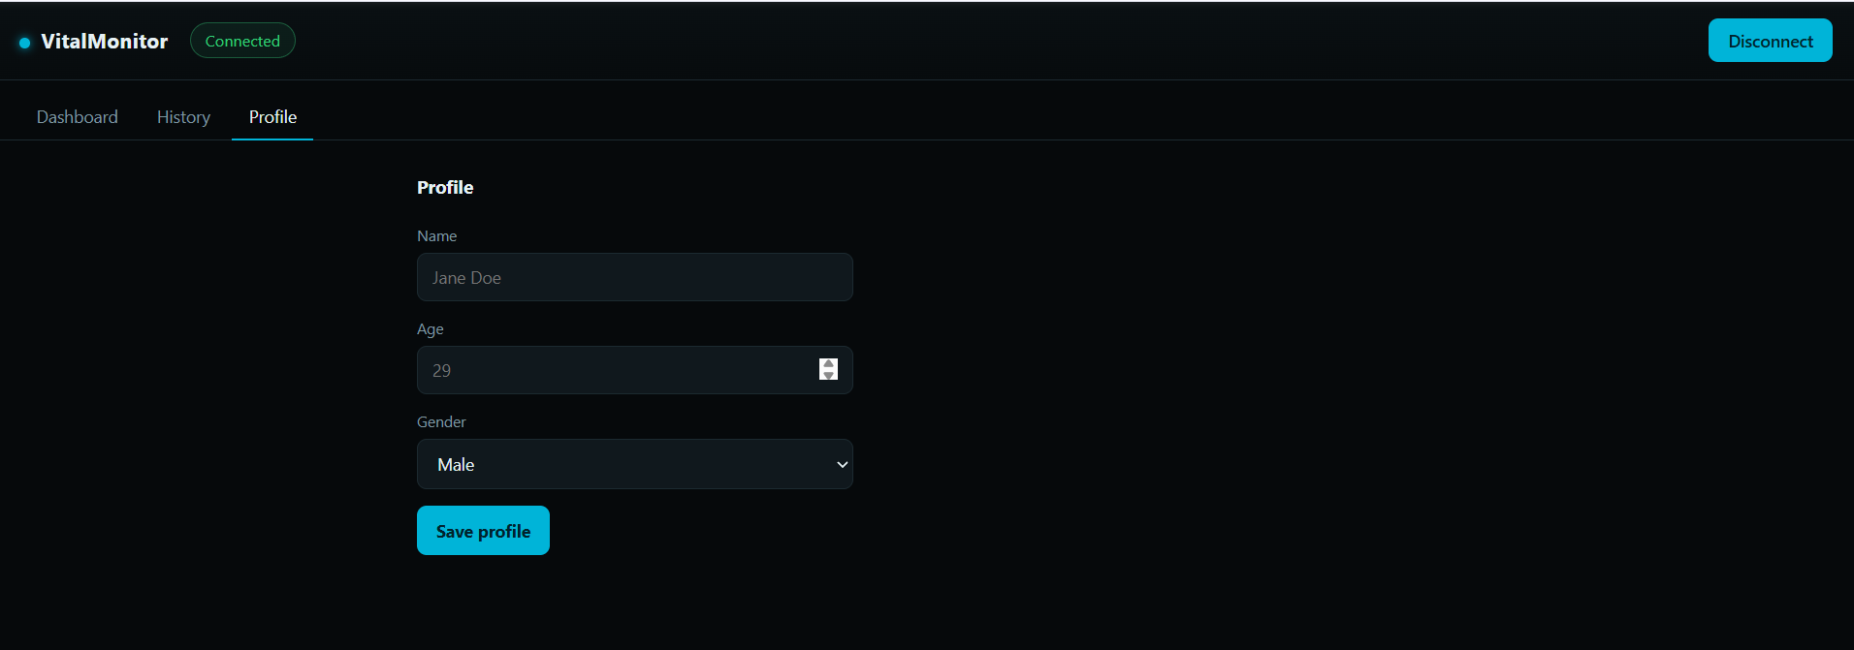

E. Take a measurement
- Click the Dashboard tab.
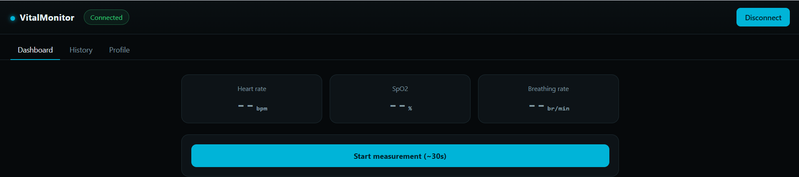
- Place your finger on the MAX30105 sensor first. Press gently and hold still. The OLED goes from "Place finger..." to "Stabilizing..." and then shows BPM. This takes about 3 seconds.
- Click Start measurement (~30s).
- The page shows six live cards: BPM, SpO2, Breathing, PM1.0, PM2.5 and PM10. A progress bar and a "30s remaining" countdown also appear. The OLED shows "Measuring... / Xs left".
- Keep your finger still for the full 30 seconds. To abort, click Stop measurement. An aborted measurement is not saved.
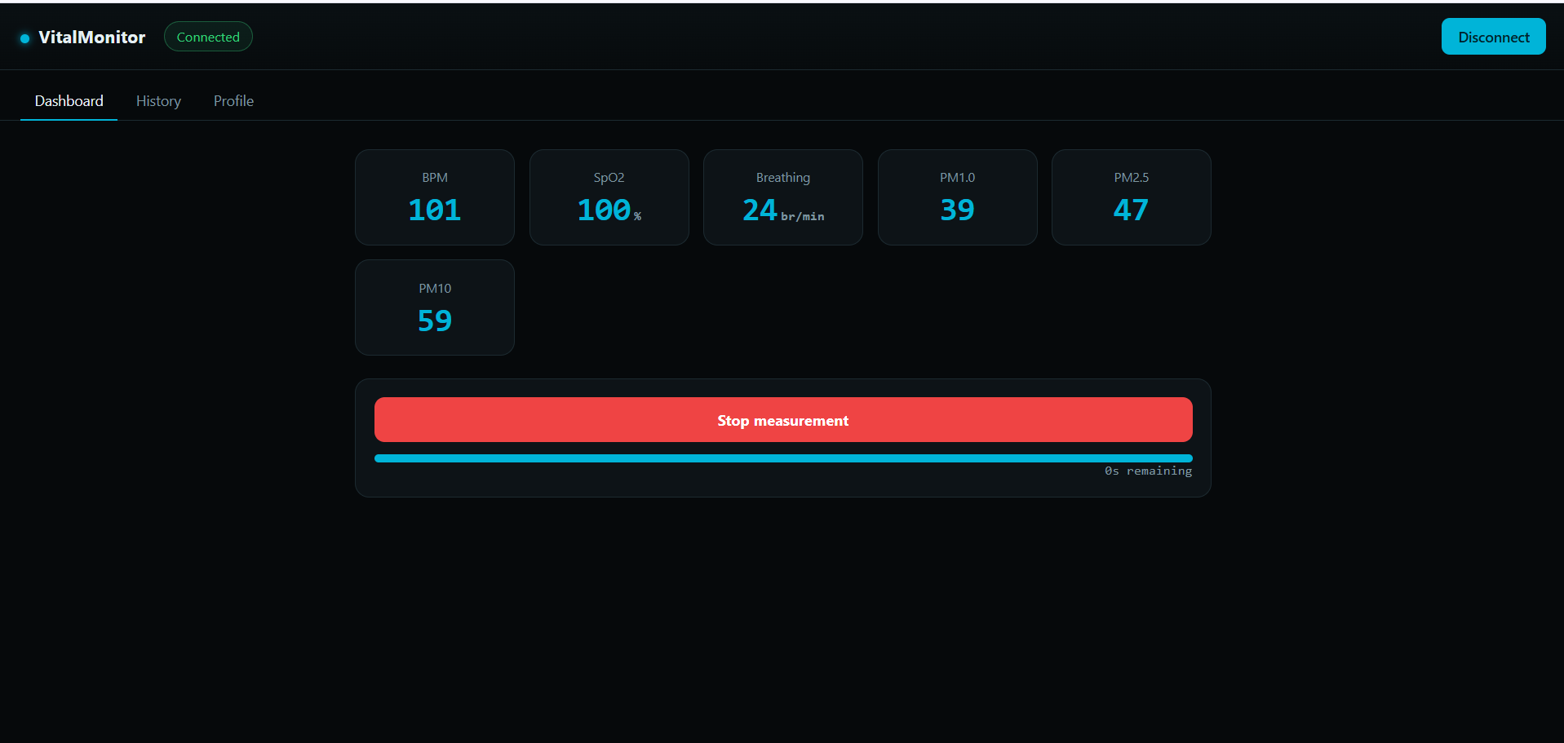
- After 30 seconds, a summary popup shows the averages and the record is saved on the device automatically.
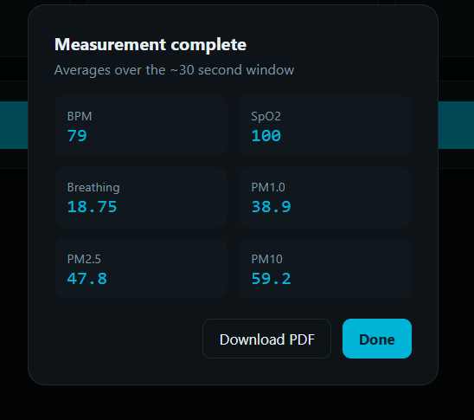

F. Download the single-measurement report
- In the popup, click Download PDF. The report is saved to your Downloads folder as vitalmonitor-report-….pdf.
- Click Done to close the popup.
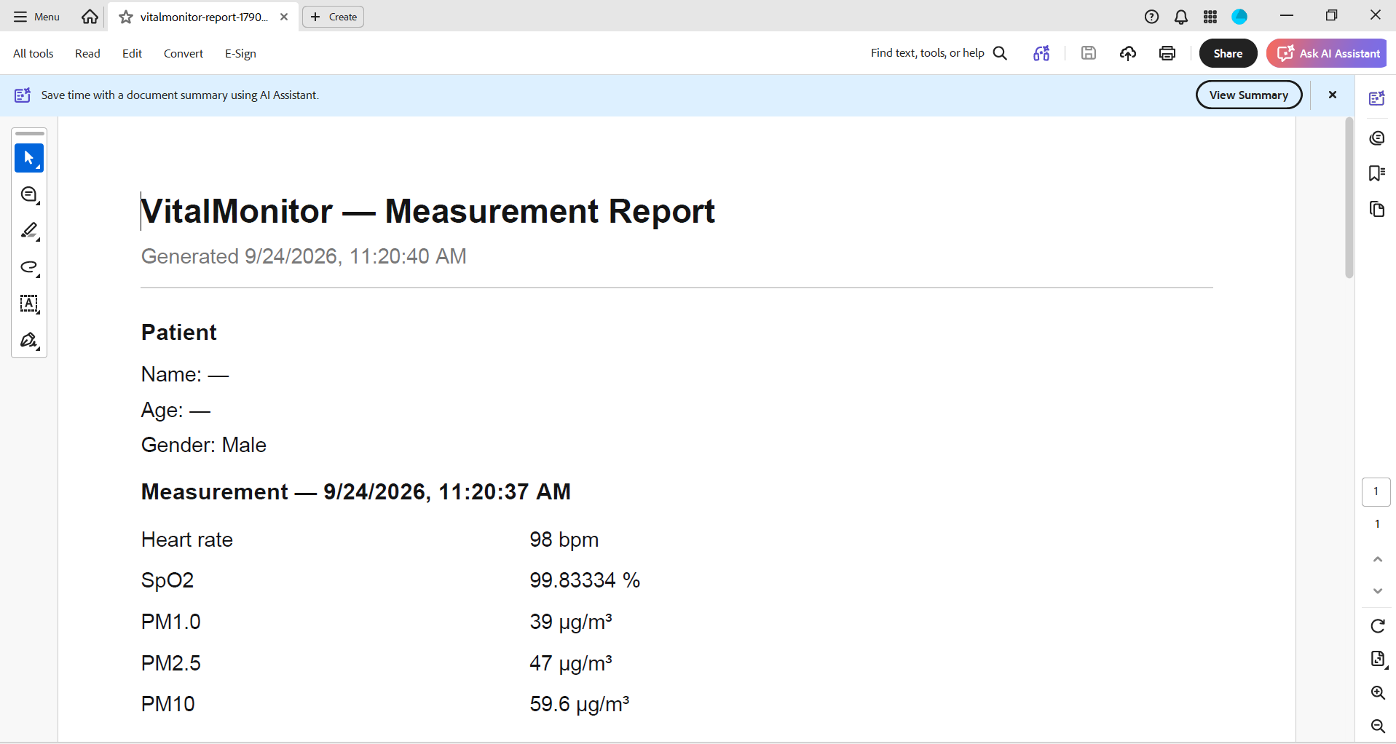
G. View history
- Click the History tab.
- The table lists Measurement, Date and time, BPM, SpO2, PM1.0, PM2.5 and PM10.
- Click Load more to see older records. It changes to "No more records" at the end.
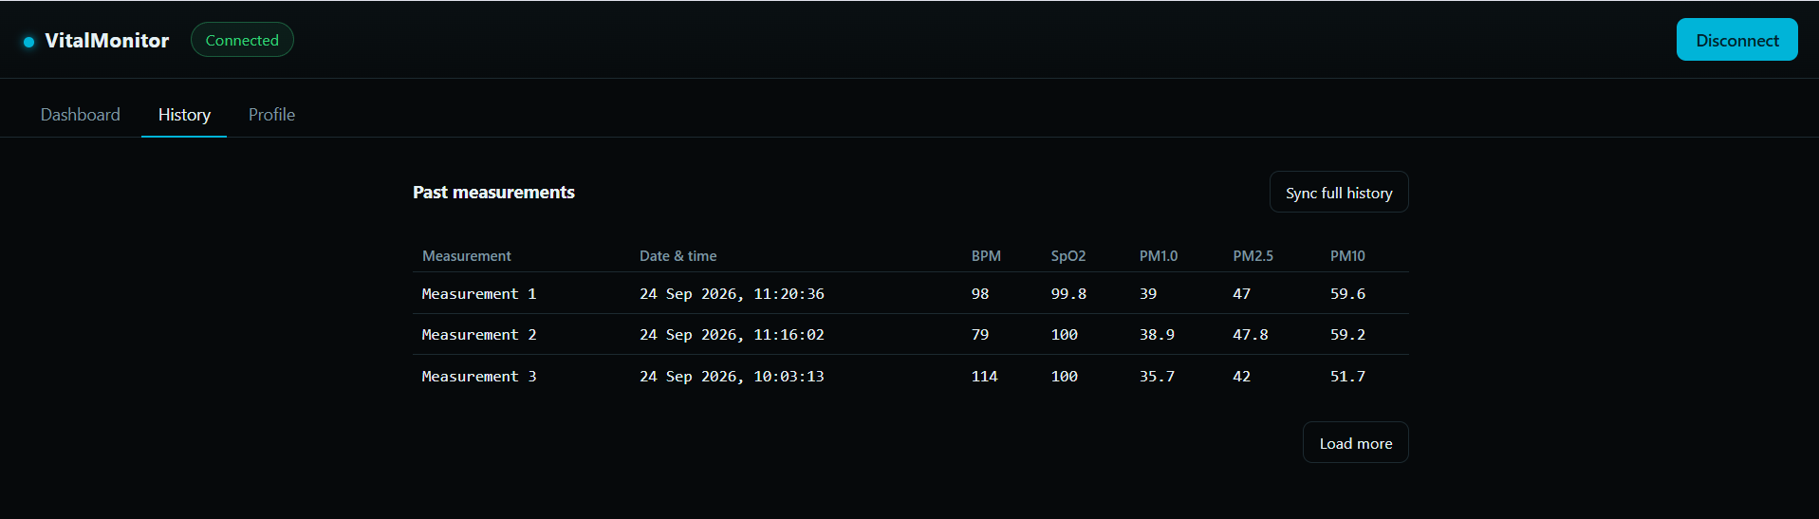
H. Download the full history PDF
- On the History tab, click Sync full history.
- A popup shows the progress ("Receiving records…" and a count such as 5 / 20). Wait until it closes. A toast says "Synced N records".
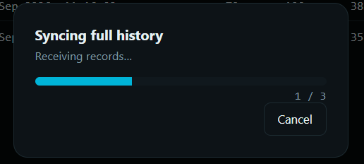
- A new row appears at the bottom with "N records ready to export" and a Download full history (PDF) button. Click it.
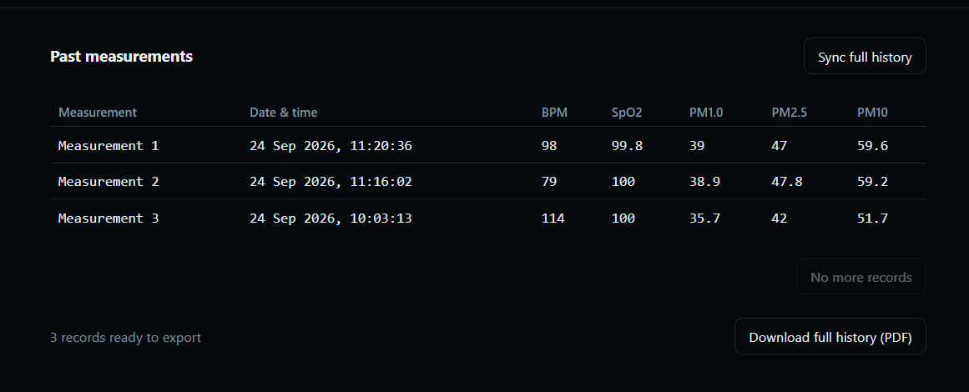

- The file is saved as vitalmonitor-history-….pdf. It has the patient info, the most recent measurement, a trend chart and a table of all measurements.

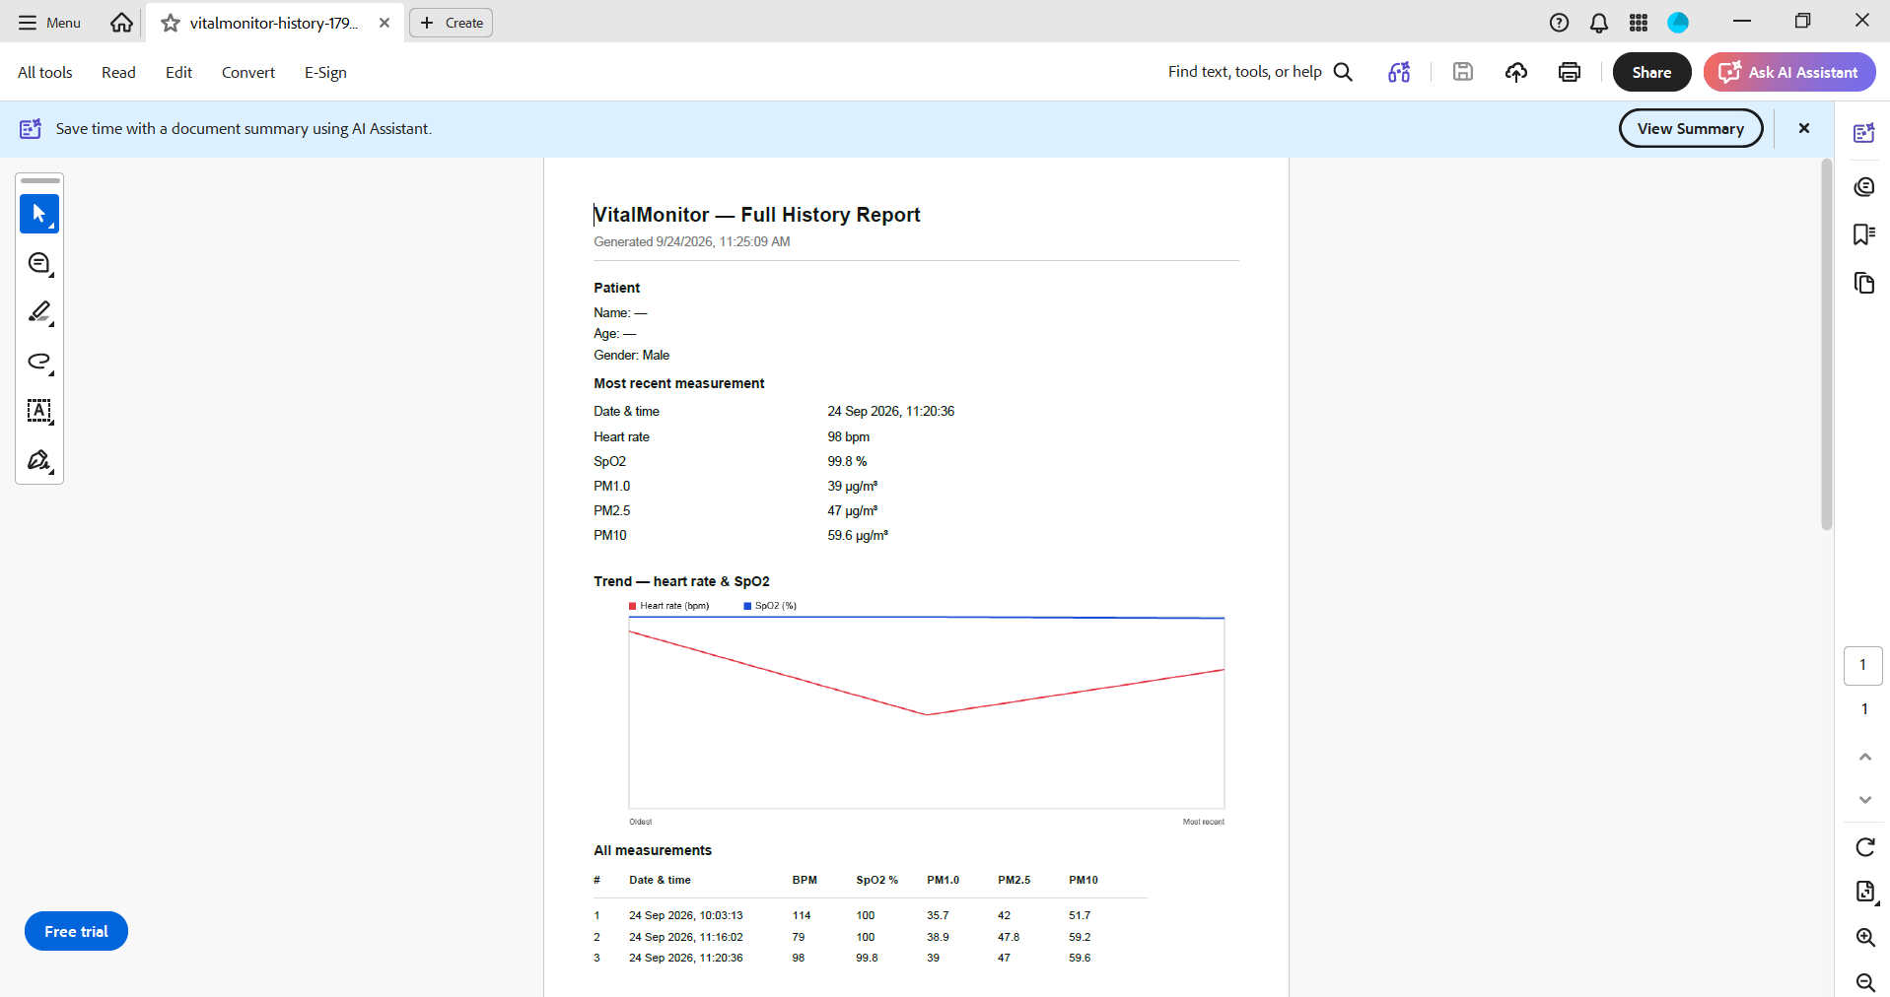

  - Disconnect
- Click Disconnect at the top right. The status goes back to Not connected, and the OLED returns to "Waiting for app".

If something goes wrong
- "Disconnected — reconnecting…" banner: move closer to the device. It retries every 2 seconds.
- The VitalMonitor device is not in the picker: check that the OLED says "Waiting for app to connect", then press the reset button on the board.
- Sync fails or times out: click Sync full history again.
- BPM or SpO2 shows "--" or averages are 0: the finger was off the sensor or moving. Place it first, then press Start.

